WARRANT OFFICER ASSOCIATION
CRATER CHAPTER # 0603
FORT LEE, VIRGINIA 23801

MEMORANDUM FOR RECORD DRAFT 4 September 2019

1. The Chapter President, CW4 Dan Howison, called the meeting to order at 1730.

2. Quorum - 14 (26 proxies) present to conduct the meeting, 46 visitors; Pledge of Allegiance was recited.

NOTE: Michael A. Norcus, Department of Game and Volunteer Instructor Program, provide a 45 minute Professional Development Seminar on changes to the 2019 Fall/Winter Hunting guidelines in Virginia. The briefing was interesting, well received, and there were many interactive questions during the brief. See Report.

3. We welcomed the following visitors:
- CW4 Crystall Gonzalez 921A
- WO1 Monroe Staples 921A
- CW4 Kevin Sims 921A
- CW5 Thomas Elder, 920A
- Michael A. Norcus, Department of Game and Volunteer Instructor Program
- Welcomed new LIFE member CW5 Sonia Graves-Riveria,920B Army Futures Command

4. Minutes from the 7 August 2019 meeting were reviewed by all. CW5 Travis Elliott made a motion to accept the minutes subject to edit, and CW4R Charlie Mills seconded. Motion passed.

5. The Treasurer’s reports for August 2019 was read by all. CW5 Thomas Waltman made a motion to accept the reports subject to audit, and CW5 Travis Elliott seconded. The treasurer’s reports for August 2019 passed.

6. Committee Reports:

a. Vice President Report CW4 Francis Pattin - Includes Membership statistics with reports from the Vice-President for Army Reserve/National Guard Affairs – CW5 James Williams- Vice-President for Retired Affairs – VACANT- and Vice-President for Junior Warrant Officer affairs VACANT- (VP-JWO) WO1 Tyrone Lander- see report.
b. Memorabilia – CW3 Karen Algernon-Wallace. See report. See report. Gave by CW4 Amy Scott
c. Volunteer Hour monitor- CW5R Vickie Vachon – see report.
d. Boy Scouts of America - CW4R Charlie Mills see report
e. JROTC High School Support – CW5 Nicole Woodyard
f. McGuire VA Support – CW5R Karen Ortiz
g. Rebuilding TriCities – CW5 Thomas Waltman -see report
h. Public Relations – CW5 Travis Elliott
i. Crater Fall Picnic / potluck - CW4 James McCracken
.
7. Old Business.

a. CW4 Amy Scott briefed memorabilia. Memorabilia sales are going well and is ‘on fire.’ CW5 Cortez Frazier, noted that we should put pictures of memorabilia items on the Crater Chapter Web Site and on Facebook.
b. CW4 Dan Howison will attend AAM in Fort Campbell, and Crater Chapter will pay for some travel cost. Dan attended the Coalition of Military Organizations in Arlington, VA, with CW4R Jack Dutiell. Topics for this year are Points for Retirement for deployed COMP 2 & 3, 79% fill rates in NG/AR;, Tuition Assistance, GI Bill choices, or a lack thereof, and Survivor Benefits.
c. CW5 Travis Elliott discussed a volunteer opportunity to paint Walnut Hill Elementary School on 300 W South Petersburg, VA 2805 at the previous meeting. Painting is 0700 to 1800 Monday thru Friday and volunteers will be taken for 2 hour shifts. CW5 Travis Elliott will be the committee lead and coordinator for this action, and will take chapter volunteers and ALU student volunteers to assist.
d. CW4 James McCracken is Fall Potluck initiative POC. CW5R Wayne Burton will assist James. Saturday, 26 October 2019 is the choice date and it will be burgers, hot-dogs, and members are urged to bring a dish. Suggestions are potato salad, broccoli salad, chili, nacho dip, Cole-slaw, cake, pie, cookies, home-made bread, French-fries, pasta salad, baked beans, Macaroni salad, Mac & Cheese, Cucumber salad, Tater Tots, baked sweet potato fries, Watermelon, Black Bean salad, Tray of sliced tomatoes, onion and lettuce for HB, hot-dog chili, home-made ice tea, and just be creative if you can cook.
e. CW5 Travis Elliot volunteered to lead the committee for a Warrant Officer Ball. Quorum discussion suggested that the spring is best for such an event, and April is the quorum choice for the event. The plan is to use the 2015 plan. Dates choices for the event are (Saturday) 18 or 25 April 2020. CW5 Elliott is coordinating the details.
f. Rebuilding TriCities: CW5 Thomas Waltman now chairs that committee. Rebuilding TriCities is listed on calendar, and in Standing Orders as a supported action. CW5R Wayne Burton provided CW5 Waltman the previous committee lead’s contact information (CW5R Reggie Jacobs).
g. CW5R Wayne Burton used solicitation letter to get meal vouchers for 2, for Members’ present raffle.
h. Holiday Helper date is 11 December 2019 from 1100-1300 hours. Thus far CW4 Francis Pattin, CW4R Charlie Mills, CW5 Travis Elliott, are volunteers to transport items, a pre-mission to enable the Holiday Helper event.
i. A motion was made to close the 2019 Chapter Election by CW5 James Williams and seconded by CW5 Maria Martinez, motion passed. The 2019 new officers are as follows. CW4 Francis Pattin is the 2019 Chapter President and CW4 James McCracken is the 2019 Chapter Vice President. New Chapter Officers will be installed in January 2020.

8. New business:

a. Members’ Present Raffle. CW5 Travis Elliott won the raffle and gave to WO1 Tyrone Lander. The Chapter President presented a voucher for $50 to CW5 Travis Elliott to the Roma’s Restaurante in Petersburg. There is additional funds from the refrigerator $50 for next month (already purchased).

9. The next meeting will be held on Wednesday, 6 November 2019 at Suite E, Bldg. 10000, near Carver Avenue and Sisisky Blvd (the Hut) at 1700, gather for social and the meeting will begin at 1730 hours.

10. Motion to adjourn was made by CW4R Charlie Mills, and was seconded by CW5 Travis Elliott at 1847. Motion passed.
______________________ ______________________
Wayne Burton Dan Y. Howison
Crater Chapter Secretary Crater Chapter President

4 September 2019 Quorum
CW4 Dan Howison  CW5R Wayne Burton  CW4 Francis Pattin  CW4R Charlie Mills  CW5 Maria Martinez  CW3 Amy S. Scott  CW5 Travis Elliott | WO1 Tyrone Lander  % CW5 Nicole Woodyard  CW5 Thomas Waltman  CW5 James Williams  CW5 Sonia Graves-Rivera  CW5 Cortez Frazier  ! CW5 Thomas Elder | CW4 James McCracken  ! CW4 Crystal Gonzalez  ! WO1 Monroe Staples  ! CW4 Kevin Sims  ! Michael A. Norcus |  | * USAWOA member; not Crater Chapter member # membership unknown ! VISITOR  %Telephone Call in
ADDENDUM: Crater Chapter Proxies Held
Crater Chapter Standing Orders:
1. Chapter President is authorized discretion to fund administrative purchases of up to $500, provided the budget contains funding. Such expenditures will be reviewed in the next Treasures Report minutes.
2. Two Scholarships are funded annually. One to a dependent of a Crater Member present in the local area and one open to student attending college in local area from the tri-cities area or other member dependent. All funds in the Chapter Savings are for Scholarships. Deviation from two scholarships or amount change in any year are actioned with a quorum motion and voting. Application guidelines are published in the entry form available on the Chapter website.
3. Chapter Memorabilia Chair is authorized to fund replenishment of existing memorabilia lines from sales proceeds up to $999.00 limit.
4. Chapter Treasure is bonded and signs all checks for Chapter expenditures; with actions reported in following Treasurer’s reports.
5. Chapter sends a representative to the AAM each year if funding is available. Raised and obligated annually NLT July permitting best scheduling and bargain travel costs.
6. Crater Chapter supports the following community events as Old Business:
- Rebuilding Tri-Cities/Habitat-for Humanity
- Thanksgiving Baskets
- Wreaths Across America
- Holiday Helper
- Support for McGuire Veterans Home ($500 per year) or more as voted
All other community events are brought to the quorum as new business.

Name Expires Proxy given to:
CW5 Jose Agosto Mar 20 Open
CW4 Adriana Aldape Mar 20 Open
CW4R Percy Alexander Jan 20 CW5R Wayne Burton
CW4 Alex Blain Mar 20 Open
CW4R Hope Bean Jan 20 CW4R Amy Jones
COLR David Buck Mar 20 Presiding Officer
CW5R Wayne Burton Jan 20 Open
CW5 Travis Elliott Jan 20 CW5R Wayne Burton
CW5R Wayne Estes Mar 20 Presiding Officer
CW5 Roberto Figueroa Jan 20 CW5R Vickie Vachon
CW5R Sam Galloway Nov 19 President
CW5R Bob Gates Jan 20 CW5R Wayne Burton
CW5 Robert Gowin Mar 20 Open
CW3 Ryan Harman Jan 20 CW4 Dan Howison
CW4 Dan Howison Mar 20 Open
CW5 Guy Hunter Mar 20 CW5R Vickie Vachon
CW4R Richard Jefferson Mar 20 VP
CW4R Amy Jones Aug 19 CW5R Wayne Burton
CW4 Robert D. Johnson Jul 20 President or VP
WO1 Tyrone Lander Jul 20 Open
CW3 Joshua Martin Mar 20 President or VP
CW4R Luis Martinez Jan 20 CWR5 Vickie Vachon
CW5R Frank Meeks Jul 20 CW5R Vickie Vachon
CW4 Wayne Melesky Nov 19 Presiding Officer
CW4R Charles L. Mills Mar 20 CW5R Wayne Burton
CW4R Chester Morris Jan 20 Chapter President
CW4R Monty Meston Jan 20 CW5R Wayne Burton
Chapter BOD – Committee Structure
President+: CW4 Dan Howison dan.y.howison.mil@mail.mil Vice President+: CW4 Francis Pattin francis.w.pattin.mil@mail.mil Vice President for Army Reserve/NG Affairs –CW5 James Williams Vice President for Retired Affairs – OPEN VP Junior Warrant Officer affairs - (VP-JWO) WO1 Tyrone Lander @Membership – Filled by VP, VP-RA, VP RS-A, Memorabilia - CW3 Karen Algernon-Wallace karen.a.algernonwallace.mil@mail.mil *Rebuilding Tri-Cities – CW5 Thomas Waltman @Nominations/Elections Committee – CW5R Wayne Burton & CW5R Vickie Vachon *Volunteer hour Monitor - CW5 Vickie Vachon (pokeandprod@aol.com ) *Holiday helper – CW5R Vickie Vachon *Web-Master – CW3 James McCracken james.mccracken13.mil@mail.mil *Boy Scouts Of America ( + Cub Scouts) CW4R Charlie Mills *JROTC High School Support – CW5 Nicole Woodyard + CW4 Jenn Walker *McGuire VA Support – CW5R Karen Ortiz *Crater 100th Committee - CW5 Nicole Woodyard *Resolutions/ Parliamentarian - CW5R Wayne Burton *Chaplain – OPEN *Warrant Officer Ball – CW5 Travis Elliott *Crater Fall Picnic / Potluck – CW4 James McCracken *Public Relations – CW5 Travis Elliott
Treasurer # – CW4R Charles Mills ( charlieandada@gmail.com ) Secretary# – CW5R Wayne Burton (waynebrv@yahoo.com; marion.w.burton.civ@mail.mil)
*Special Committee + elected office # appointed office @ Committee IAW Bylaws
Note: All Elected/Appointed Officers and Committee leads will serve on Crater BOD.

All committee members & appointments are installed and removed at discretion of the Chapter President IAW current Chapter Bylaws
CW3R William King Mar 20 Presiding Officer
CW5R Karen Ortiz Jan 20 CW5R Vickie Vachon
CW3 Dan Peoples Mar 20 CW5R Wayne Burton
CW4 Francis Pattin Jan 20 CW5R Wayne Burton
CW4R Allan E Rickard Mar 20 Presiding Officer
CW4 Wayne Sexton July 20 Open
CW5R Alvin Taswell Aug 19 Open
CW5R Vickie Vachon Jul 20 President or VP
CW4 Ted Vanzant Mar 20 CW5R Wayne Burton
CW4 Clenora ”Jenn” Walker Mar 20 Open
CW3 Gabriela Wetherington May 20 CW4 Francis Pattin
CW5 James Williams Mar 20 Open
CW5 Nicole Woodyard Feb 20 Open
CW4R Donna Zampi Oct 19 President

Proxies used:
Bronze Level - Eagle Rising Recipients:
CW5R Wayne Burton CW4 Dan Howison
CW4 Adriana Aldape CW4 Ted Vanzant
CW4 Francis Pattin CW4R Charlie Mills
CW2 Kevin Pick CW5 Nicole Woodyard USAWOA

Silver Level - Eagle Rising Recipients
CW4R Amy Jones CW5 James Williams
CW5 Nicole Woodyard USAOWA

Gold Level - Eagle Rising Recipients
CW5R Vickie Vachon CW5R Wayne Burton
CW5 Travis Elliott
CW5 Guy Hunter CW5R Karen Ortiz
CW4 Adriana Aldape CW5 Nicole Woodyard USAOWA

Presidents’ Report – Verbal report at meeting.
Vice Presidents’ Report
Vice President NOTES:
CW3 Francis Pattin– Chapter Vice President, CW5 James WIlliams VP – Reserve/NG Affairs, and VACANT VP- Retired Affairs WO1 Tyrone Lander
NOTE: Revalidation is at least a 6 month process, therefore POA revalidation efforts must begin in February 2020, to meet Oct deadline.
Crater Chapter POA revision will be as the Crater Silver Chapter, USAWOA

Crater 2019-2020 Calendar Events

6 Nov Chapter Meeting – HUT
- Audit
- Holiday Helper donation & planning list
- Wreaths Across America planning list
- Election Vote
4 Dec Chapter Meeting - HUT
- Announce election results
- Holiday Helper execution
- Visit McGuire Veterans Hospital
- Wreaths Across America
- Audit
8 Jan 2020- Swear in elected new officers
5 Feb 2020 – Crater paperwork needs filled out and submitted for Private Organization Revalidation
VP Report - Roster

ADW | 62
RET | 68
ARW | 5
NGW | 6
ASC | 1
Life | 71
Total | 144

Crater Meeting Call in Number
1-712-770-5505
Access Code: 501219
Calling in to the Crater Meeting is like being here in person. If you are a member, YOU may participate, open motions, offer seconds, discuss and vote. We all are busy, and the Crater Chapter steps up to the 21st Century with live telephonic meeting!

VOLUNTEER HOURS
Volunteer hours as of 1525 hours 5 November 2019 are:

Members - 3953.5

Guest – 257.0

Volunteer Hours (Need ages of volunteers always if younger than 18)

Boy Scouts of America, Troop 912, Ft Lee Va. Charles L .Mills

Boy Scouts of America, Troop 912, Ft Lee Va.

September HAPPENINGS
Time for Transition to next level in the scouting program
Updating medical forms as directed by BSA
New committee chairperson appointed

Discussion on upcoming events and plans for training activities:

Plans for September:
Troop campout
Charles L .Mills
USAWOA, Crater Chapter
Charter Organization Representative

Boy Scouts of America, Troop 912, Ft Lee Va.
October HAPPENINGS

During troop meetings, Adult and youth leadership had discussions of upcoming events and plans for training activities.

Training events: Dutch-oven Cooking, First Aid, Lashing, How to build a raft, CPR

Please remember that a subject of training (Cooking) not only pertains to the specific subject but it also pertains to everything that may lead up to the specific subject. I. E: What type of wood to use, how to start a fire, how / why to cooking properly and how to put out a fire and of course First aid is always reiterated.

Event:
18-20 Oct, Campout at camp Albright
22 Oct Troop meeting, with a focus on upcoming election for troop youth leadership.

Memorabilia
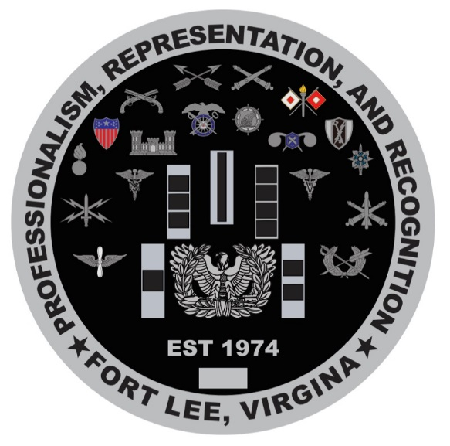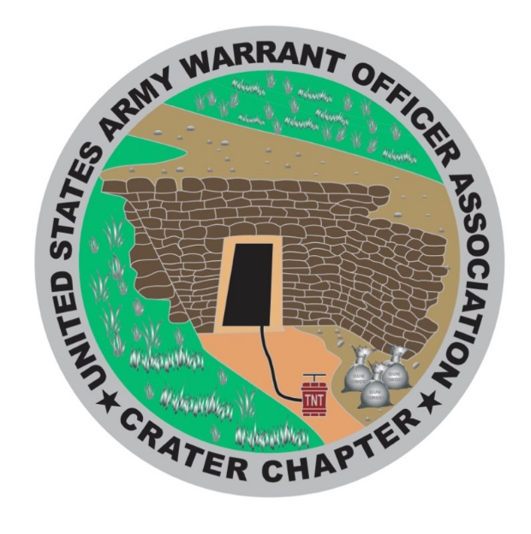

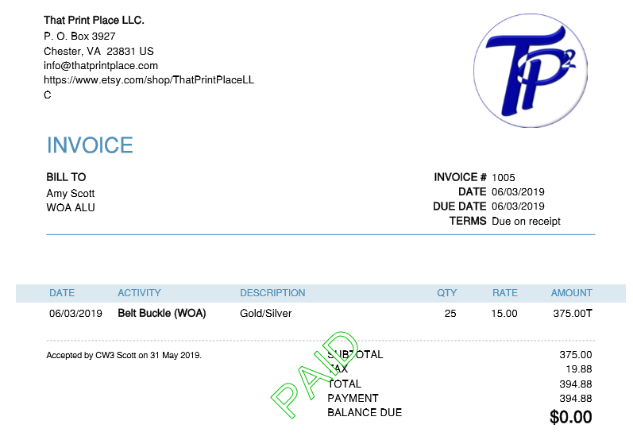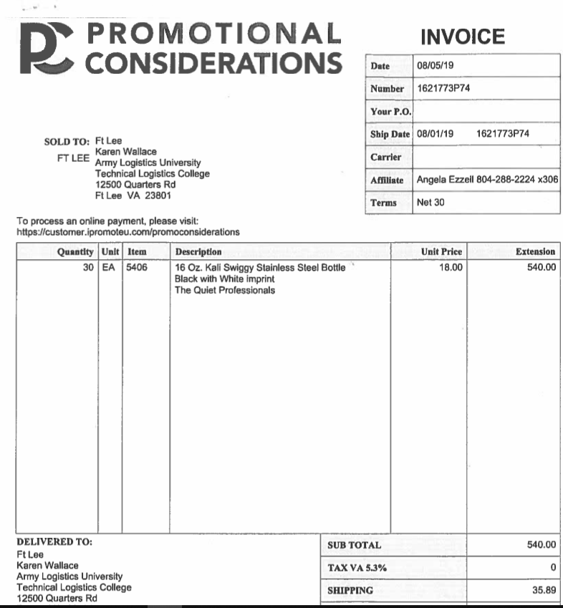

USAWOA CRATER CHAPTER
Treasurer’s Reports
1 September 2019 – 30 September 2019

Checking Account Fort Lee Federal Credit Union- Balance previous month $ 2,567.32

INCOME:
National rebate $ 18.00
Memorabilia $ 1,006.00
Income Total $ 1,024.00 + $ 1,024.00

Expenses:
None
Expenditures Total: $ 00.00 - $ 00.00
Total Revenue = $ 3,591.32
---------------------------------------------------------------------------------------------------------------------
Savings Account Fort Lee Federal Credit Union - Balance previous month $ 3,061.54

Income: None
Expenditures: None
Saving Account Balance: $ 3,061.54
----------------------------------------------------------------------------------------------------------------------

PLEDGED PAID
Mail Box: $ 62.00
Liability Insurance: $ 268.00 $268.00
Bond: $ 114.82 $114.82
Scholarship Member: $1,000.00 $1,000.00
Scholarship Community: $1,000.00 0.00
Thanksgiving Donation: $ 250.00
Christmas Donation: $ 250.00
AMM: $3,000.00
Re-Building Tri-City: $ 200.00
Scouts – BSA: $ 200.00 $200.00
Veterans Home: $ 300.00
TOTAL $6,644.82 $1,582.82

Pledged Donation for 2019 $6,644.82
Spent $1,582.82
Removed from pledge $ 1,000.00
Remaining Obligation $5,062.00

Charles L. Mills Dan Y. Howison
CW4(R), OD CW4, OD
Crater Chapter Treasurer Crater Chapter President

USAWOA CRATER CHAPTER
Treasurer’s Reports
1 October 2019 – 30 October 2019

Checking Account Fort Lee Federal Credit Union- Balance previous month $ 3,591.32

INCOME:
Memorabilia $ 250.00
Memorabilia $ 100.00
Interest $ .35
Income Total $ 350.35 + $ 350.35

Expenses:
Memorabilia $ 485.89
Memorabilia $ 90.00
Picnic $ 400.00 Check #’s 133 & 135
ACS $ 250.00 Check # 134
Expenditures Total: $ 1,225.89 - $ 1,225.89 Total Revenue = $ 2,715.78 ---------------------------------------------------------------------------------------------------------------------
Savings Account Fort Lee Federal Credit Union - Balance previous month $ 3,061.54

Income: Interest $ 1.93
Expenditures: None
Saving Account Balance: $ 3,063.47 $ 3,063.47
----------------------------------------------------------------------------------------------------------------------

PLEDGED PAID
Mail Box: $ 62.00
Liability Insurance: $ 268.00 $ 268.00
Bond: $ 114.82 $ 114.82
Scholarship Member: $1,000.00 $1,000.00
Scholarship Community: $1,000.00 0.00
Thanksgiving Donation: $ 250.00 $ 250.00
Christmas Donation: $ 250.00
AMM: $3,000.00
Re-Building Tri-City: $ 200.00
Scouts – BSA: $ 200.00 $ 200.00
Veterans Home: $ 300.00
TOTAL $6,644.82 $1,832.82

Charles L. Mills Dan Y. Howison
CW4(R), OD CW4, OD
Crater Chapter Treasurer Crater Chapter President

From: Joy Metzger <mail4joymetzger@gmail.com>
To: pokeandprod <pokeandprod@aol.com>
Sent: Mon, Oct 28, 2019 11:01 am
Subject: Dollar Tree Stores for WO Association

Vickie,

Thanks for chatting this morning. Attached is the spreadsheet with the 9 remaining stores for the WO Association. We are so happy that you want to be part of this project! Please note that the available stores are the ones without names. We can discuss the details of how you want to proceed when I meet with your group Wednesday, 6 November at 1730 somewhere behind the DCMA building. :-)

I sent an email this morning to you and other volunteers that gives in depth information about Operation Homefront, Dollar Tree Corporate and Holiday Helper and how we all fit into the puzzle.

Just want you to have the addresses and phone numbers of your stores and the flyer needed to access the stores to pick up the boxes.

Look forward to seeing you next week and ironing out the details.

Kind regards,
Joy

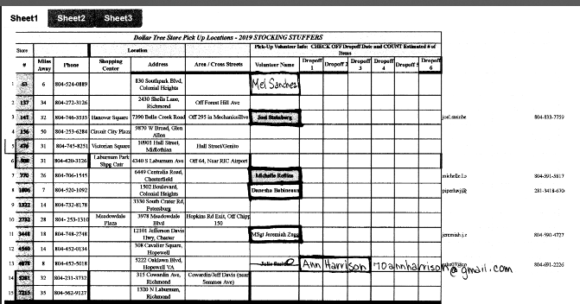

Proposed Christmas Event at McGuire Veterans Hospital
The Crater Chapter Warrant Officer Association Fort Lee, indicates they would like to host a breakfast buffet for Christmas for our Veterans. Tomeka Graham understands there is another group willing to do the same, and hopes these two groups will be able to link up
POC CW5R Karen Ortiz.

Members Raffle: Names were drawn and CW5 Travis Elliott won the Crater Chapter Members Raffle. Travis in turn, gave his certificate to WO1 Tyrone Lander
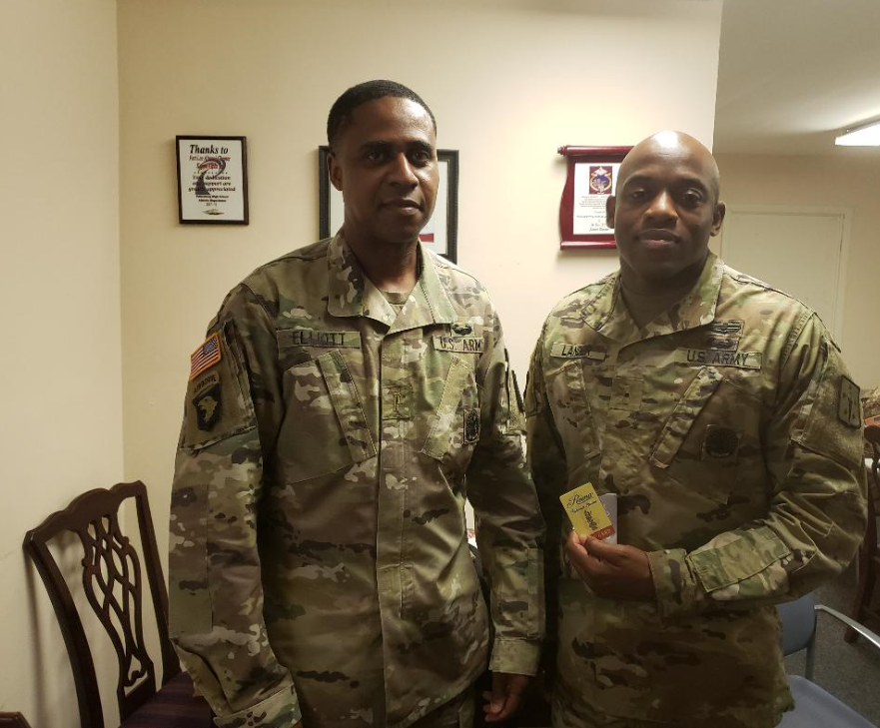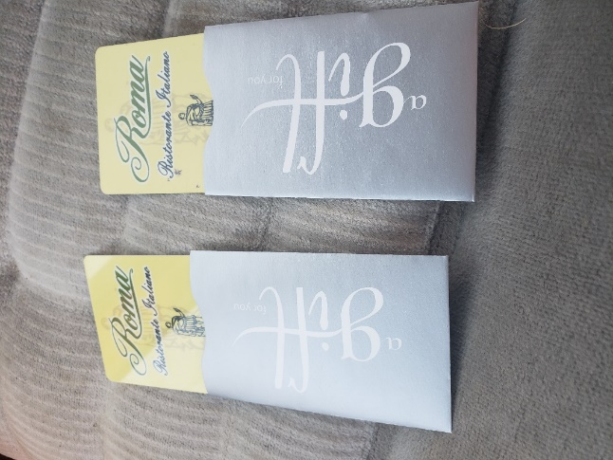

Roma’s Restaurant Meal for Two Gift Certificates.
CW5R Wayne Burton coordinated with the manager of Romas and gained a 20% off offer for the Chapter for a $50 Meal Gift Certificate Card for TWO, for only $40. He bought 2 cards with available funds from the refrigerator. These gift certificates will be drawn from a raffle, once a month, from Crater members names at the chapter meeting and also from those calling in. The odds to win are awesome. Last month, it was one in eight. The Dining for Two gift certificates are for members only, with the intent to give incentive to meeting attendance or to call in. We believe it is time to give back to the members and their family, those who come and make things happen for the Crater Chapter. Thus far, the cost have come from purchase from the Refrigerator funds and generous donations.

Pot-luck
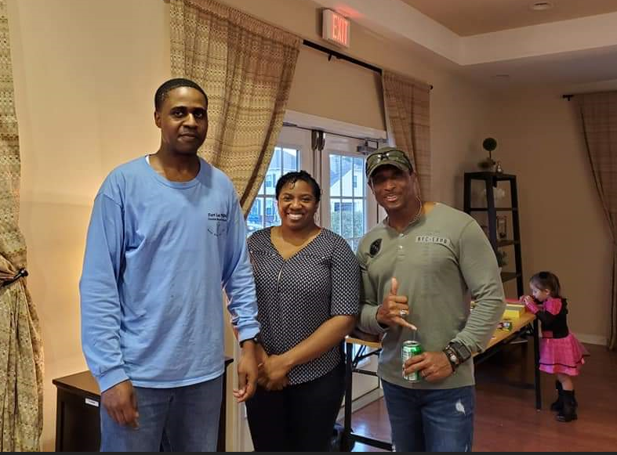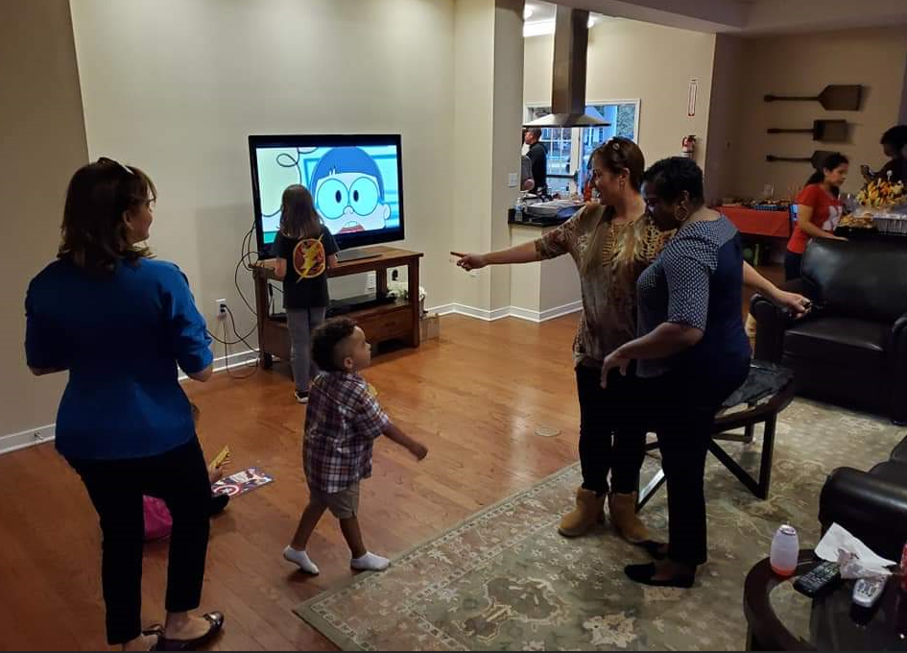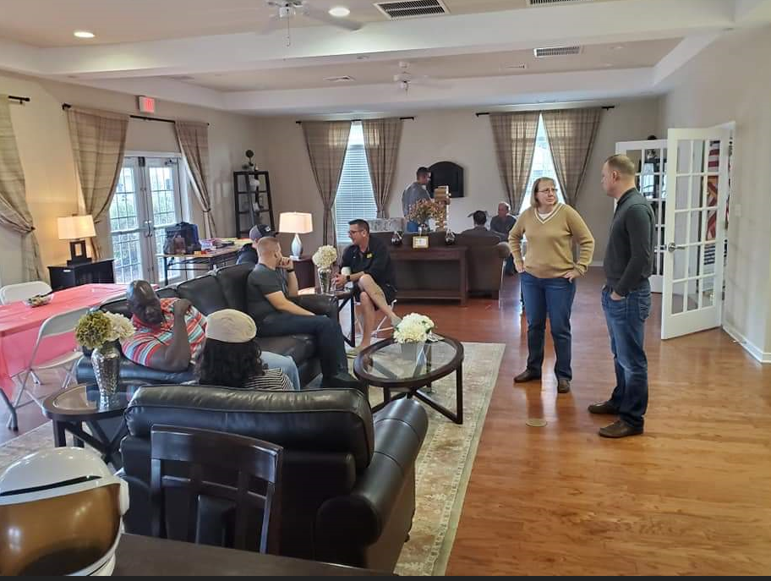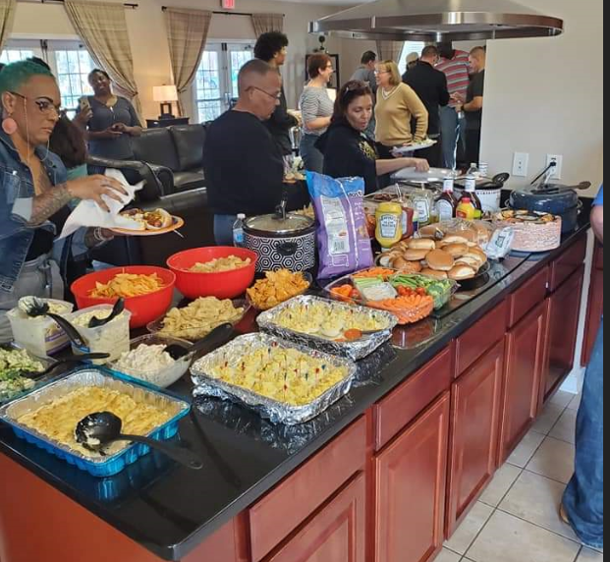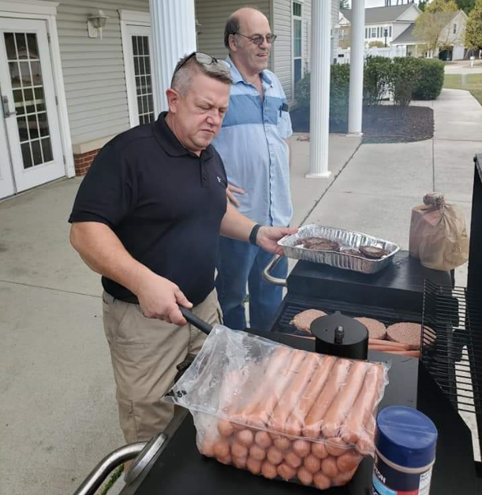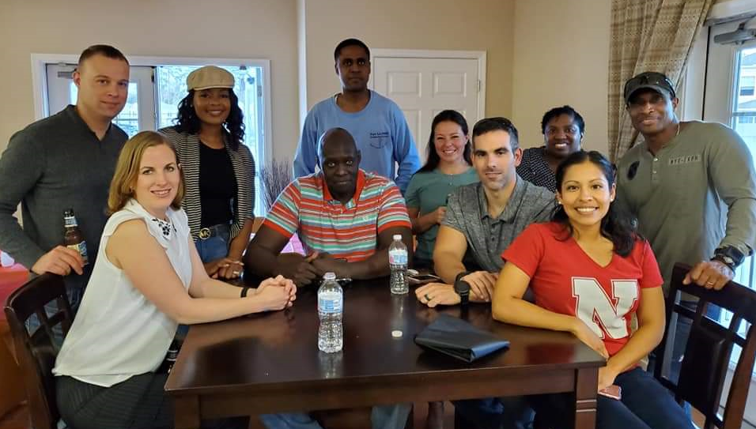
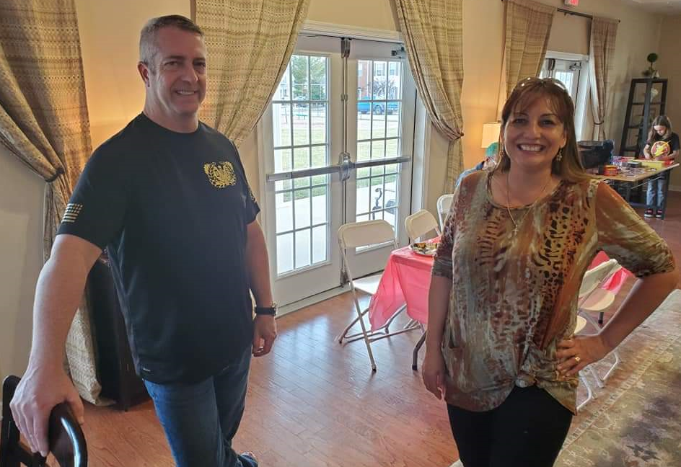
POTLUCK: 1600-1930 26 October 2019 at Community Center 465 York Drive. 30 people attended. The potluck and on-site food preparation revealed the comradery and esprit de corps of the WOA. Potluck was led by CW4 James McCracken and CW5 Travis Elliott. The beginning of more to come.

Agenda November 6th, 2019 meeting
1. Count of members to ensure a forum/forum established ( ) ID Proxies ( )
2. Call meeting to order at _________________
3. Pledge
4. Welcome guest and new members
5. Minutes passed out and read, any discussion, motion to accept subject to edit
Motion made by ________________________________
Seconded By ___________________________________
6. Treasures Report read and any discussion, motion to accept subject to audit
Motion made by_________________________________
Seconded By ____________________________________
7. Committee Reports
a. Vice President Report CW4 Francis Pattin – CW5 James Williams- WO1 Tyrone Lander
b. Memorabilia – CW3 Karen Algernon-Wallace.
d. Volunteer Hours - CW5R Vickie Vachon.
e. Holiday Helper - CW5R Vickie Vachon.
f. Boy Scouts - CW4R Charlie Mills
g. Solicitation – CW5 Nicole Woodyard
h. JROTC – CW5 Nicole Woodyard.
i. WO Ball – CW5 Travis Elliott
j. Rebuilding TriCities – CW5 Thomas Waltman
k. Public Relations – CW5 Travis Elliott
8. Old Business

What’s in it for me? –action
Proposed Christmas Event At McGuire Veterans Hospital –action
Chapter coin review – action
Fall pot-luck CW4 McCracken – Report & AAR

9. New Business –

10. Alibi’s
11. Next Meeting - 6 November 2019- Suite E, Bldg. 10000, near Carver Avenue & Sisisky Blvd (the Hut) at 1730
12. Adjourn meeting at (time) _________________________
Motion made by__________________________________
Seconded by _____________________________________

CRATER CHAPTER NOTES:
______________________________________________________________________________________________________________________________________________________________________________________________________________________________________________________________________________________________________________________________________________________________________________________________________________________________________________________________________________________________________________________________________________________________________________________________________________________________________________________________________________________________________________________________________________________________________________________________________________________________________________________________________________________________________________________________________________________________________________________________________________________________________________________________________________________________________________________________________________________________________________________________________________________________________________________________________________________________________________________________________________________________________________________________________________________________________________________________________________________________________________________________________________________________________________________________________________________________________________________

